
Development Request
Aria Systems
Material PO Temporary Receiving (Custom# 102694)

New Program Template Description

New Program Template

Material PO Temporary Receiving
Product: | Aria2.7
Module: | MA
Customer name: | Bratex (BRA14)
Installed Modules: | AL, AR, AS, AP, EB, CRM, GL, IC, MA, MF, PDM, RM, SM, SO, SR, UP
Parameters setting: | They are set-up to use Extended Size Scale. They have GL linked to the system. They are setup to use Lot costing and keeping track of Rolls for MA module. They are also setup to use Dyelots for MA and IC (finished goods). They are also using Multi Currency.

System Setting Report:
We need to get a list of all system settings.
You can export the system settings through Aria 2.7 as follows:
Select the menu “User” then the Menu Option “Settings” then the submenu option “Export System Settings” then finally write down the file name to which settings will be saved.

Details Section
Screen Name: Material PO Temporary Receiving
Screen Objective: This will give Bratex the ability to receive Material PO’s in a Temporary stage. The purpose of this is to allow Quality Control dept. time to inspect goods for quality before updating their live inventory.

Existing Initial situation: None

Detail Description: We will create a new screen for Bratex called “Material PO Temporary Receiving”. The objective of this program is to allow Bratex to receive a Material Purchase Order in a temporary stage so that Quality Control Dept could inspect goods before updating that inventory into their live On-Hand stock. This temporary screen will be similar to our standard temporary screens (i.e. Style PO Temporary Receiving or Cutting Ticket Temporary Receiving screens). This custom program will also include a report, which will allow the users to view the temporary receiving. They would also like to modify the Material Screen by adding a new screen on the “Option Menu” called “View Temporary Received”. The logic behind this customization is that Material Warehouse will receive the goods from a purchase order. They have to receive the goods that came in before quality control has the time to inspect the merchandise do to the volume of orders. The type of receiving that material warehouse will do is a temporary receiving. They also have to remove it from On-Order flag since the merchandise is physically in their warehouse and not pending in a order. Quality Control will then inspect the goods and either receives the temporary received order into their live system or makes modifications to the temporary received and then receive into inventory.

Existing Situation:

- Purchase Order department creates material purchase orders
- Material On-Order is increased based on the material purchase order quantities
- Once material goods arrive into their warehouse location Bratex only has the option to receive the Material PO’s which will update their On-Hand and remove the QTY from On-Order stage
- Quality Control will either have to inspect the goods before Material warehouse can receive the goods into inventory, which will keep material goods as On-Order even though materials are physically in warehouse, or inspect after they have received the material goods and then make adjustments if necessary.

Material PO Temporary Receiving screen:

- The Material PO Temporary receiving screen will be the same our standard Material PO receiving screen except that instead of updating the On-Hand total it will place the materials in a temporary stage which will allow Quality Control department to inspect the goods before receiving
- The “Material PO Temporary Receiving screen” will have all the option and functions that the Material PO receiving screen has except when the user “Saves” the receiving it will remove the material from On-Order and place the Material PO into a

temporary receiving stage.
- We will also include a “Status” field which will allow the user to mark that temporary receiving batch as “Open” or “Approved”
- “Approved” – This value will allow the user to go to Material Receive PO screen and receive the batch that was created in the Temporary receiving screen
- “Open” – This value will not allow the user to receive this Temporary batch on the Material PO receiving screen. The user must first “Approve” the batch then they will be able to receive into inventory. (NOTE that this logic is similar to Cutting Ticket Temporary receiving in the MF module and you can refer to that screen for these fields functions)
- The Material PO Temporary Receiving screen will also include a “Batch#” field in which the user can browse for already created batches to either view, edit or delete them.
- The user will have the ability to temporary receive several Material Purchase Orders into one batch number. Then the user can receive that batch in the Material Receive PO screen
- Once a temporary receive session is made for a Material Purchase Order and saved it will deplete the amount received from the “On-Order” for that material and place that inventory into a “Temporary” received inventory. The user will be able to see this inventory by going to the “Material screen” and clicking on the “Option” menu and selecting the screen “View Temporary Received”.

Material Receive PO screen

- We must add a new field on the Material Receive PO screen called “Receive”. This will be a dropdown list with the following values: “Material PO” and “Batch No”
- “Batch No” – If this field is selected the user will have the ability to receive a batch number that was created from the Temporary Receiving screen. The “P/O #” field will be replaced by the “Batch #” field in which the user can select a batch number to receive instead of a Material PO
- “Material PO” – This will be the default value of the “Receive” field. If this value is selected the Material Receive PO screen will work as it normally does without any changes

Material Screen

- We will add a new field on the screen “Material” screen called “Temp”. This field will be activated by the user clicking on the “View Temporary Received” menu option located on the “Option” menu of the material screen.
- This field will be placed between the “Receivings” and “Work in Process” fields on the “Quantities “tab folder.
- This field will be similar to the “On-Order” fields in which the user can click on that field and view more detail information about which Temporary Receivings add up to the total “Temp” quantity. From that screen the user will also be allowed to select the Batch number which will open the Material Temporary Receive PO screen and display the information for that batch number

Material Temporary Receive PO report:

- Their will also be a Temporary Receiving report similar to the Material PO receipt Log in which the user can view information received in that batch number.
- This report will display the information that was updated on the Temporary Receive PO screen.
- This report will also Include a Selection Grid to give the user filtering options

Material Temporary Receive PO Selection Grid:

- “Receiving Date” – This will be a range field in which the user can enter a range of dates that the Temporary receiving batch was created
- “Temporary Receive” – This field will be an “Inlist” field. The user will have the option to select one or several Batch No to print. The user will also have the option to select a Range of “Batch No” if they choose to
- “Material Item” – This will be a “Inlist” field in which the user can select one or several Material Items to print. They will also have a Range option in which they can select a range of Material Items if they choose to. If the user selects a Material Item then the report will look for which Temporary receivings contain that Material item. Once found the report will display the information for that batch number also including other materials that are located in that batch number (if any).
- “Print by Roll” – This will be a dropdown list field with the following options: “Yes” and “No”. If “Yes” value is selected the Temporary Receive PO report will include details of Roll information. “No” value will be the default of this field.

Material Temporary Receive PO report Layout:

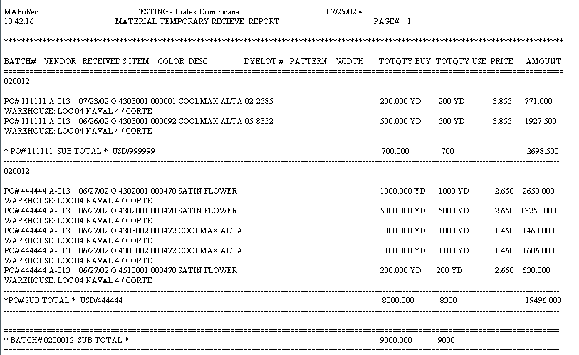

Questions (08/22/2002):
- Could you please send us the layout if the user selects to print by Rolls. We would like to know if there are specific information about the rolls that they would like to see and where shall we print them in the report.

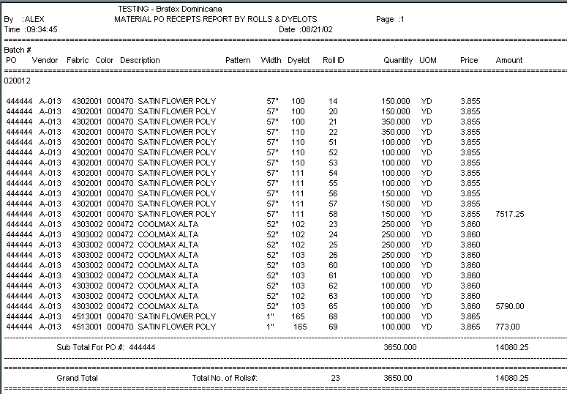

Notes…As you can see the layout is similar to the layout in our standard Receipt Log report. The only difference is that I am including the price for each Roll that I received it in. There is also an “Amount” field on the report. This amount will be place in the last Roll of a Material Color with the total Price Amount as shown in the report.

